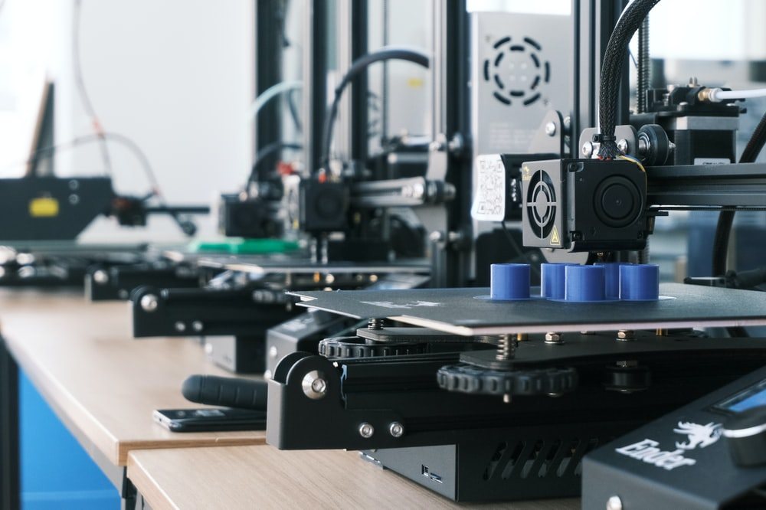
Additive Manufacturing (https://unsplash.com/s/photos/additive-manufacturing)
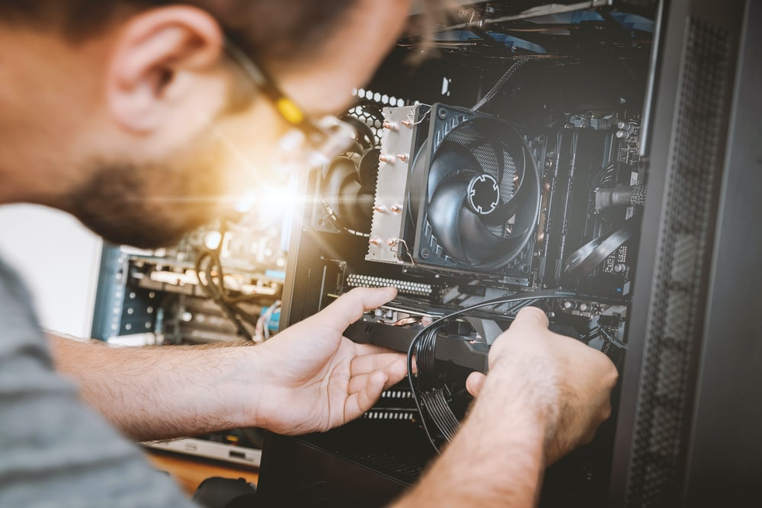
Digital Manufacturing (https://unsplash.com/s/photos/digital-manufacturing)

Big Data Analytics in Manufacturing (https://unsplash.com/photos/hpjSkU2UYSU)

Smart Materials (https://unsplash.com/s/photos/smart-materials)

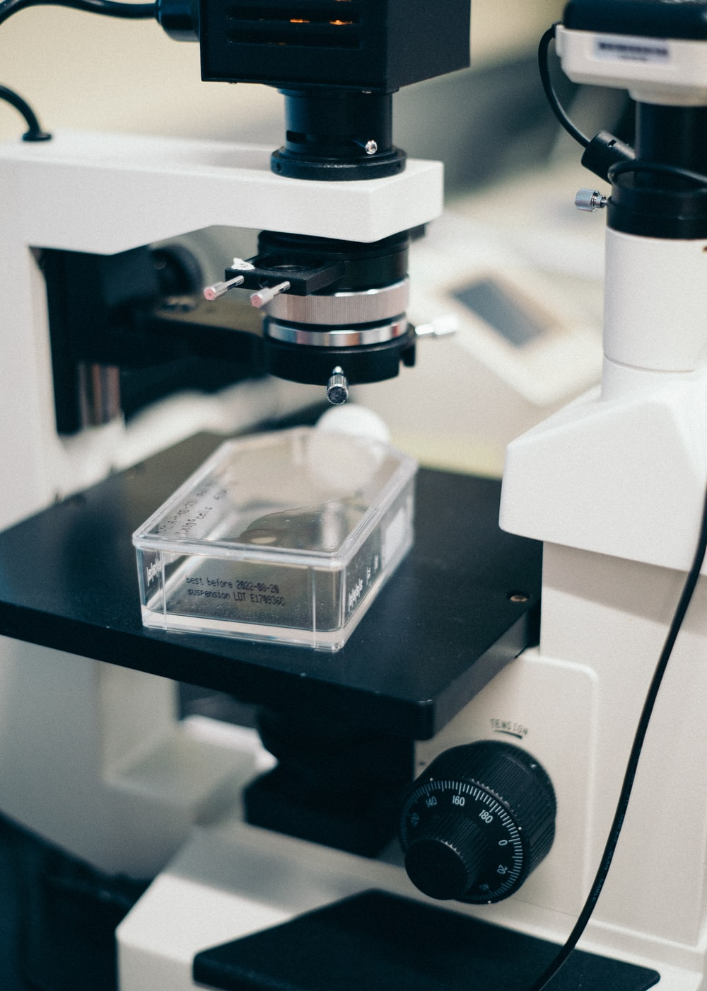
https://unsplash.com/photos/5HbxyB0_DBg (Microscopes)
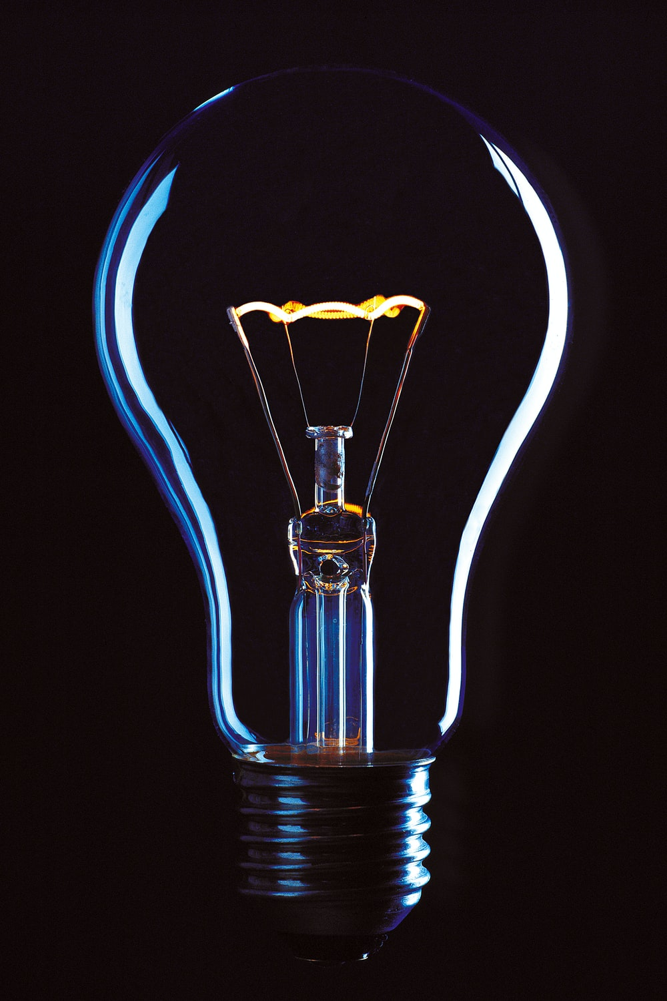
https://unsplash.com/photos/_kdTyfnUFAc (Energy Storage Devices)

https://unsplash.com/photos/l2mIRNeGWoA (Energy Storage Devices)

https://unsplash.com/photos/85Ki4n1dsZw (Energy Storage Devices)

